GOAL KEEPER RETENTION POLICY
SCOPE
This policy is to encourage and promote players in both the Development and Competitive Leagues to assume the role of keeper on a part time or full time basis. It applies to both the 11 a-side and 9 a-side divisions.
INTRODUCTION
The CUSC will refund the equivalent of one regular registration fee per team (not including the OSA registration fee or the competitive supplement cost) for players who are selected to play the full-time or part-time keeper position during the season.
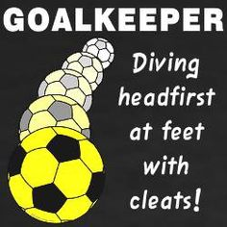
SELECTION CRITERIA
To qualify players must:
- Be selected by the team officials based on their ability to become keepers;
- Be committed to attend games and practices on a regular base; and
- In the case of Development League goalkeepers, participate (at their own cost) in two thirds (2/3) of the Introduction to Keeper Clinics or equivalent as approved by the CUSC Board of Directors; or
- In the case of Competitive League goalkeepers, participate (at their own cost) in two thirds (2/3) of the Professional Keeper Clinics or equivalent as approved by the Club Head Coach or Goalkeeper Program Director.
REIMBURSEMENT
When submitting the year-end report to the CUSC Administrator, the coach will include the name of the players who assumed the role of full-time or part-time keepers throughout the season. The coach’s report will include confirmation from the Goalkeeper Program Director of the attendance by the player, the total number of games played by the team and the number of games the player assumed the role of keeper.

A cheque in proportion to the attendance will be issued, by the CUSC Treasurer, to the player(s) for the reimbursement of the CUSC portion of the registration fee less both the OSA registration fee and competitive supplement cost when applicable.

Approved for EXTERNAL use
by the CUSC Board of Directors
May 12, 2015

